CUSTOMER CHURN PREDICTION & LTV ENGINE

Week 2 Progress Report

Prepared By:
Archita Jar

Internship Domain:
Data Analytics

Date:
22 June 2026

Objective
The objective of Week 2 was to prepare the dataset for machine learning, engineer useful features, and build predictive models to identify customers who are likely to churn.
Tools Used
- Python
- Pandas
- Scikit-Learn
- VS Code
- PostgreSQL
- pgAdmin 4
1. Data Preprocessing
Target Variable Encoding
The target variable Churn was converted into numerical format:
- Yes → 1
- No → 0
This conversion was necessary because machine learning algorithms require numerical input.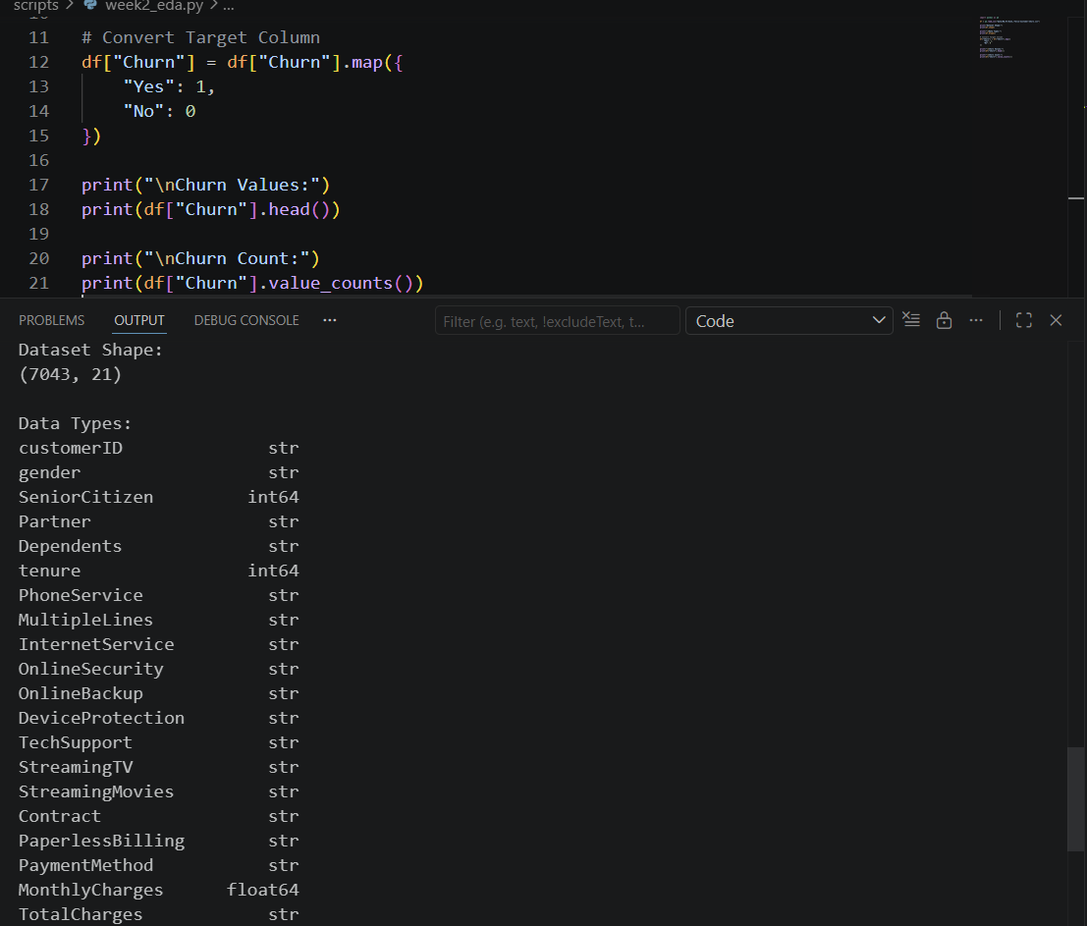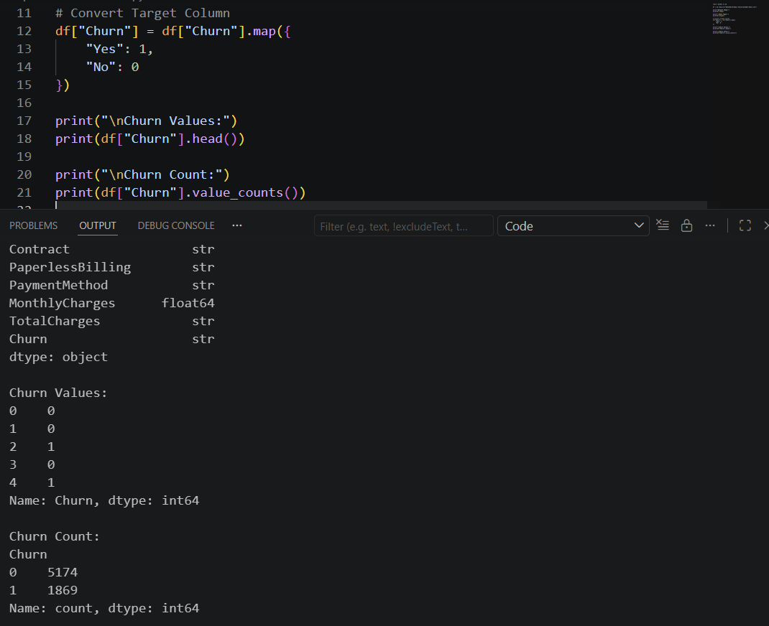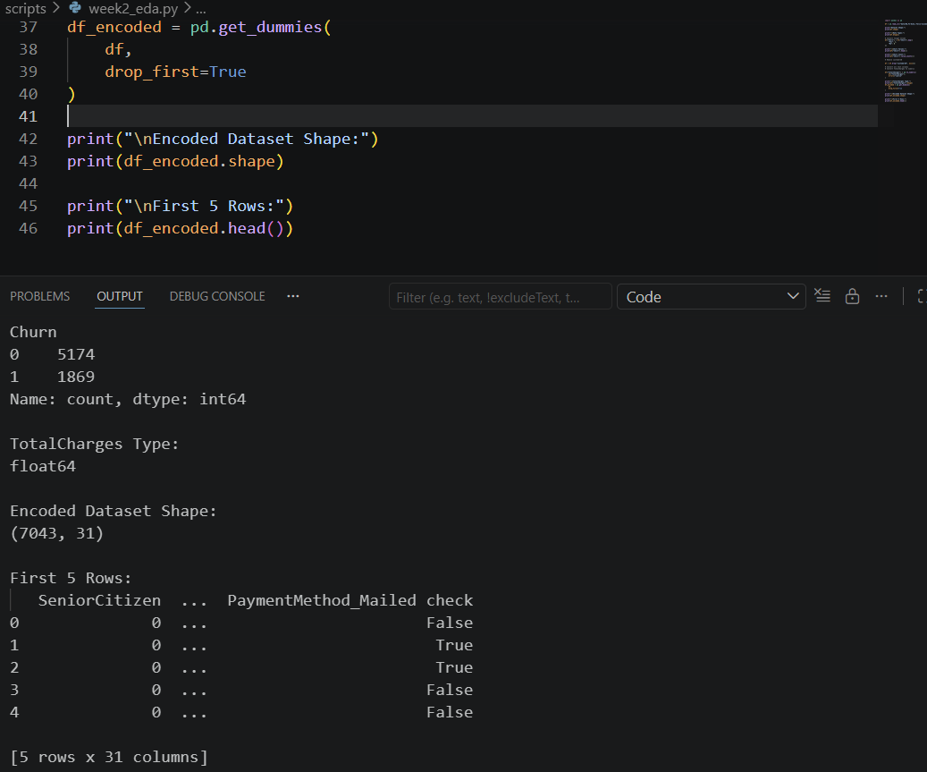
Figure 1: Churn Target Encoding Output
Removal of Irrelevant Features
The customerID column was removed from the dataset because it is a unique identifier and does not contribute to churn prediction.
Data Type Conversion
The TotalCharges column was converted from string format to numeric format. Missing values were handled using appropriate preprocessing techniques.
One-Hot Encoding
Categorical features such as Contract, PaymentMethod, InternetService, and others were converted into numerical form using One-Hot Encoding.
After encoding:
- Original Dataset Shape: (7043, 21)
- Encoded Dataset Shape: (7043, 31)

2. Feature Engineering
Feature Created: AvgMonthlySpend
A new feature named AvgMonthlySpend was created using the formula:
AvgMonthlySpend = TotalCharges / (tenure + 1)
The additional value of 1 was added to avoid division by zero for customers with zero tenure.
Business Insight
Average Monthly Spend by Churn Status:
Churn Status | AvgMonthlySpend
No | 57.66
Yes | 62.68
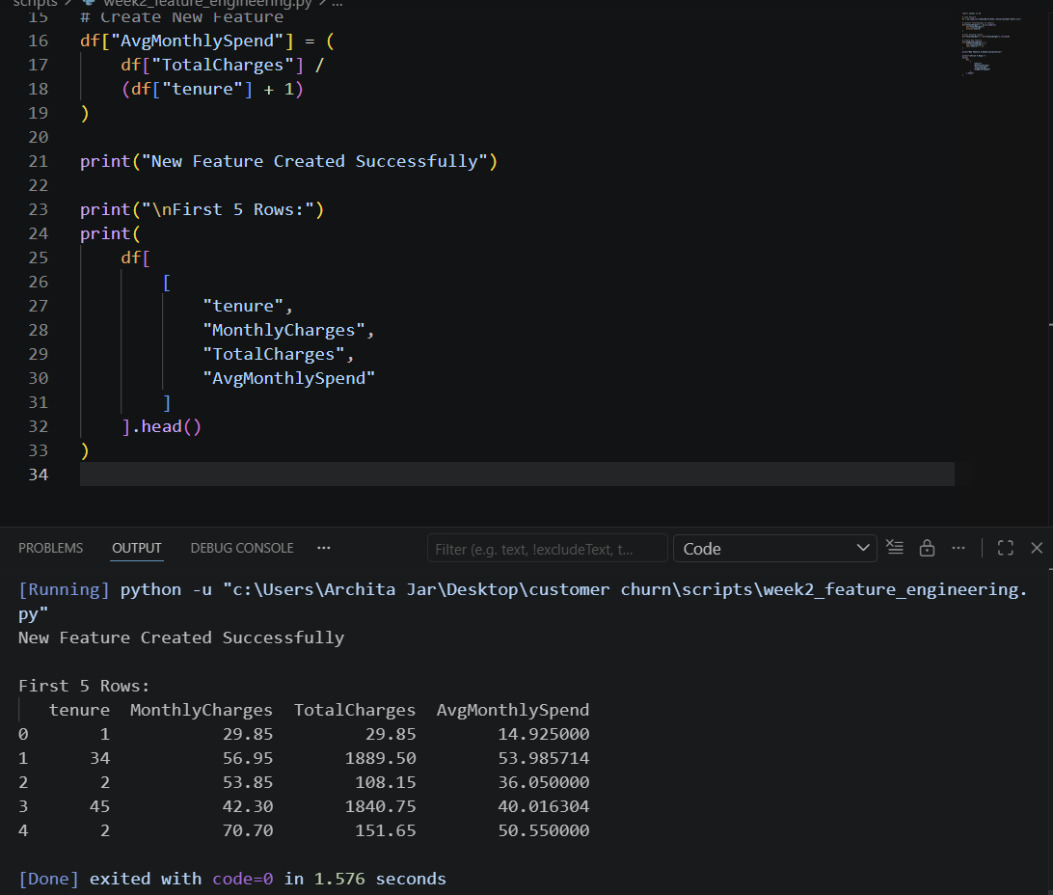
Figure 2: Creation of AvgMonthlySpend Feature
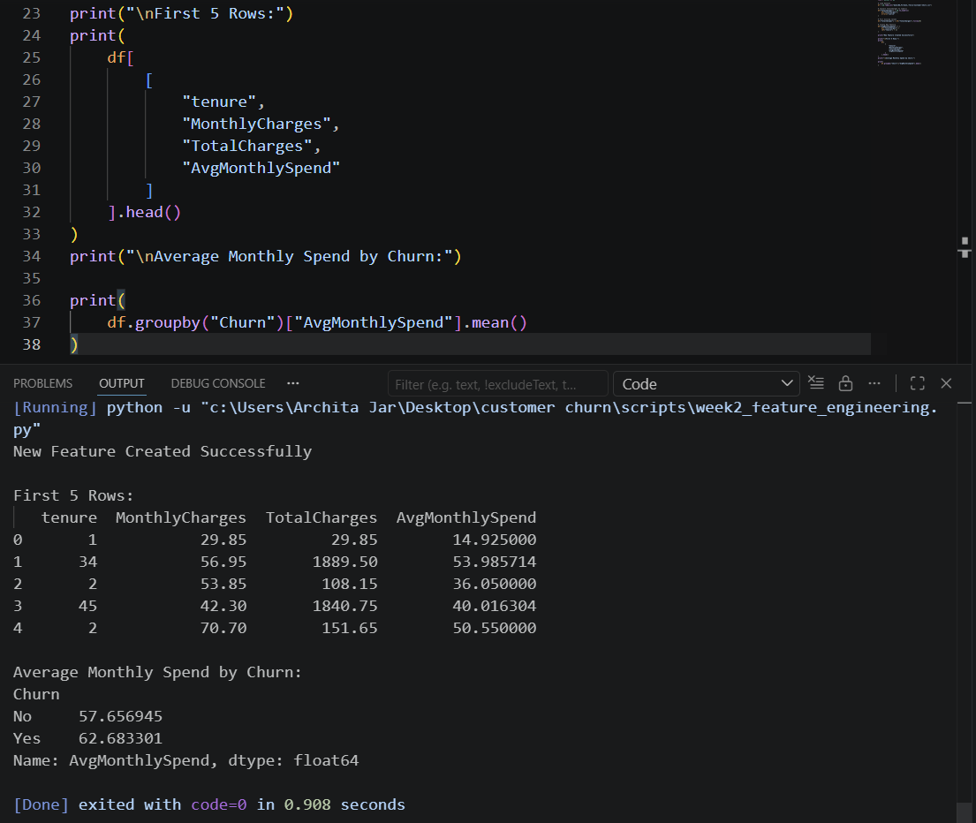
Figure 3: Average Monthly Spend by Churn Status

Observation:
Customers who churned showed a higher average monthly spending pattern compared to customers who remained with the company. This indicates that customers with higher monthly expenditure may be more likely to discontinue the service. Customers who churned had a higher average monthly spending value (62.68) compared to retained customers (57.66), suggesting that high-spending customers may still leave if their expectations are not met.

3. Train-Test Split
The dataset was divided into training and testing sets using an 80:20 ratio.
Training Set
- Records: 5634
- Features: 30
Testing Set
- Records: 1409
- Features: 30
This split allows the model to be trained on historical data and evaluated on unseen data.
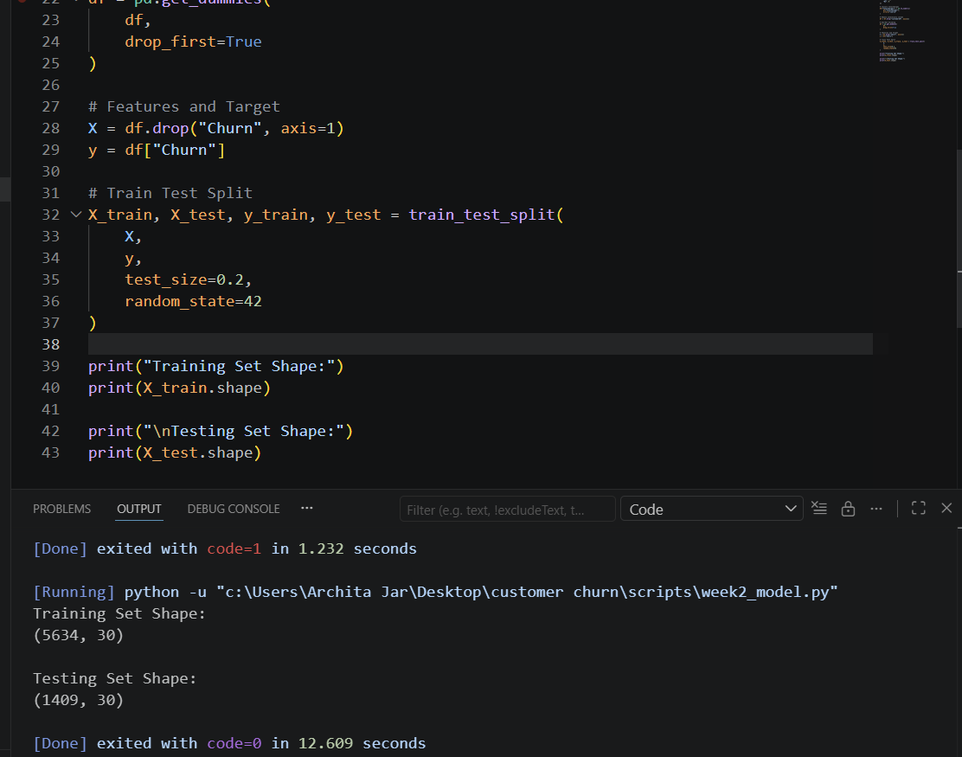
Figure 4: Train-Test Split Results

4. Logistic Regression Model
Model Training
A Logistic Regression classifier was trained using the processed dataset.
Results
Metric | Value
Accuracy | 82.11%
Precision | 0.685
Recall | 0.601
F1 Score | 0.640
Confusion Matrix
[[933 103]
[149 224]] 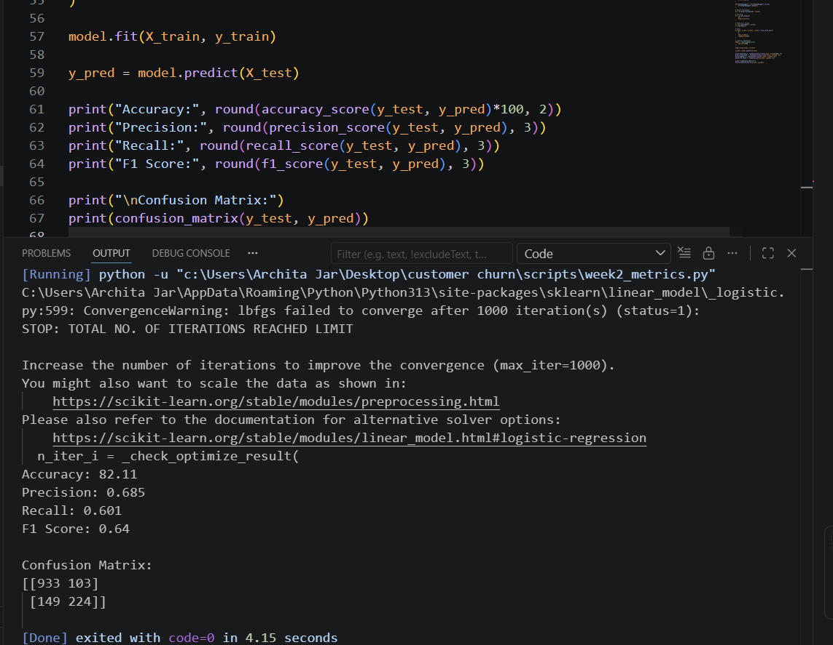
Figure 5: Logistic Regression Evaluation Metrics

Interpretation
The Logistic Regression model correctly classified approximately 82% of customer records. The model demonstrated balanced predictive performance across precision and recall metrics.

5. Random Forest Model
Model Training
A Random Forest classifier was trained using 100 decision trees.
Results
Metric | Value
Accuracy | 78.92%

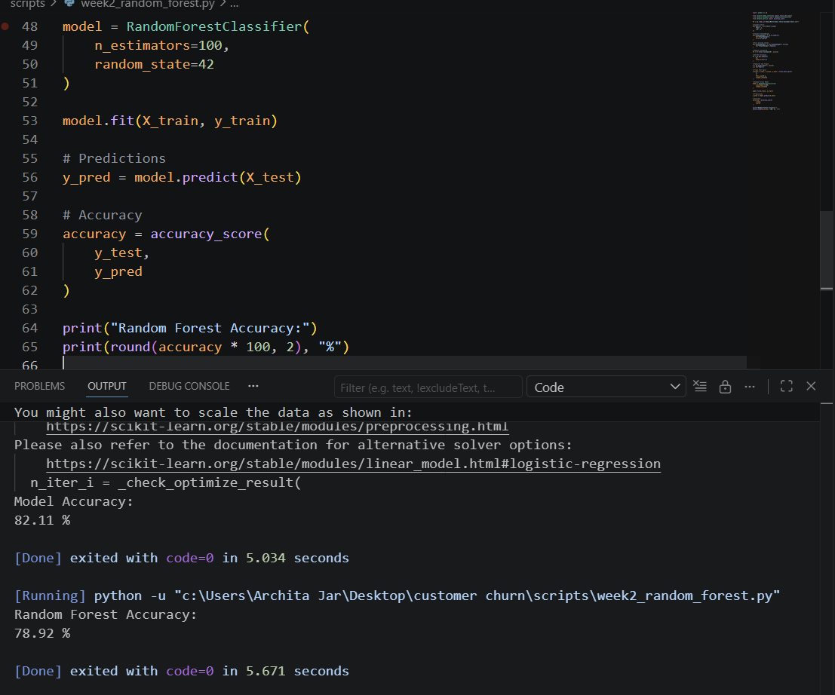Figure 6: Random Forest Accuracy Results
Interpretation
The Random Forest model achieved an accuracy of 78.92%. Although it performed reasonably well, Logistic Regression produced better overall results on this dataset.

6. Model Comparison
Model | Accuracy
Logistic Regression | 82.11%
Random Forest | 78.92%
Best Performing Model
Logistic Regression achieved the highest accuracy and was selected as the preferred model for customer churn prediction.
Future Work
- Implement XGBoost model.
- Perform feature importance analysis using SHAP.
- Optimize model performance through hyperparameter tuning.

Conclusion
During Week 2, data preprocessing, feature engineering, and predictive modeling tasks were successfully completed. A new feature (AvgMonthlySpend) was engineered to capture customer spending behavior. Two machine learning models were trained and evaluated. Logistic Regression achieved the best performance with an accuracy of 82.11%, making it the most suitable model for churn prediction in the current implementation. The developed model can assist businesses in identifying customers at risk of churn and support proactive retention strategies.

